Chapter 4 – The Last of the Spirits
The Phantom slowly, gravely, silently approached. When it came, Scrooge bent down upon his knee; for in the very air through which this Spirit moved it seemed to scatter gloom and mystery.
It was shrouded in a deep black garment, which hid its head, its face, its form, and left nothing of it visible save one outstretched hand. It was difficult to distinguish it from the black night and separate it from the darkness by which it was surrounded.
“Are you the Ghost of Christmas Yet to Come?” asked Scrooge, “I fear you more than any other spirit.”
The ghost did not say a word, and Scrooge’s legs trembled beneath him; he found that he could hardly stand when he prepared to follow it.
“I know your purpose is to do me good,” said Scrooge. “Lead on!”
They wandered into the heart of the city amongst the merchants, and the Spirit stopped beside one little knot of business men. Observing that the hand was pointed to them, Scrooge advanced to listen to their talk.
“No,'' said a large man with a monstrous chin, ``I don't know much about it, either way. I only know he's dead.''

“When did he die?'' inquired another.

“Last night, I believe.''

“Why, what was the matter with him?'' asked a third, “I thought he'd never die.''

“God knows,'' said the first, with a yawn.
“What has he done with his money?'' asked a red-faced gentleman with a pendulous excrescence on the end of his nose. “That’s what I want to know!”
“I haven't heard,'' said the man with the large chin, yawning again. ``Left it to his Company, perhaps. He hasn't left it to me. That's all I know.''

This pleasantry was received with a general laugh. Speakers and listeners strolled away, and mixed with other groups. Scrooge knew the men, and looked towards the Spirit for an explanation.
The Phantom glided on into a street without a word. Following, Scrooge resolved to treasure up every word he heard and everything he saw, despite not knowing what all this meant. He especially resolved to observe the shadow of himself when it appeared, for he had an inkling that the conduct of his future self would give him the clue he was missing.
The Ghost led them away from the busy scene and into an obscure part of the town, where Scrooge had never been before, although he had heard of it bad reputation; the whole place reeked of crime, filth and misery.
Down one of the foul, narrow alleyways was a shop owned by an elderly crook, who was inviting in some of his fellow thieves into his den. As they talked, it became apparent to Scrooge that they had brought stolen objects with them and were making fun of the person who once owned those things.
“Ha, ha!” laughed a woman, “Why wasn’t he kinder in his lifetime? If he had been, he’d have had somebody to look after him when he was dying, instead of lying gasping out his last breath all alone!”
As each of the thieves presented their goods to the shop owner to sell, they kept making their taunts.
“Should I buy this? He didn’t die of anything catching, did he?”
“He frightened everybody away from him when he was alive, to profit us when he was dead! Ha, ha, ha!”
“Spirit!'' said Scrooge, shuddering from head to foot. “I see, I see. The case of this unhappy man might be my own. If there is any person in the town, who feels emotion caused by a death, show that person to me, Spirit, I beseech you!''
The Phantom spread its dark robe before him for a moment and the scene changed. The Ghost led Scrooge through streets that were familiar to him; as they went along, Scrooge looked here and there to find himself, but nowhere was he to be seen. They entered poor Bob Cratchit’s house and found the mother and the children by the fire.
Quiet. Very quiet. The noisy little Cratchits were as still as statues. When Bob Cratchit came in, the children hurried to greet him. Then the two young Cratchits got upon his knees and laid their little cheeks against his face as if to say, “Don’t mind it, father. Don’t be sad.”
“You went there today?” said his wife.
“Yes, my dear,” returned Bob. “I wish you could have gone. It would have done you good to see how green the place is. But you’ll see it often. I promised him that we would walk there every Sunday. My little, little child.” cried Bob. “My little child.”
He broke down in tears. He couldn’t help it. He left the room, and went up-stairs into the room above, which was lighted cheerfully, and hung with Christmas.
“Spectre,” said Scrooge, “something tells me that our parting moment is at hand.”
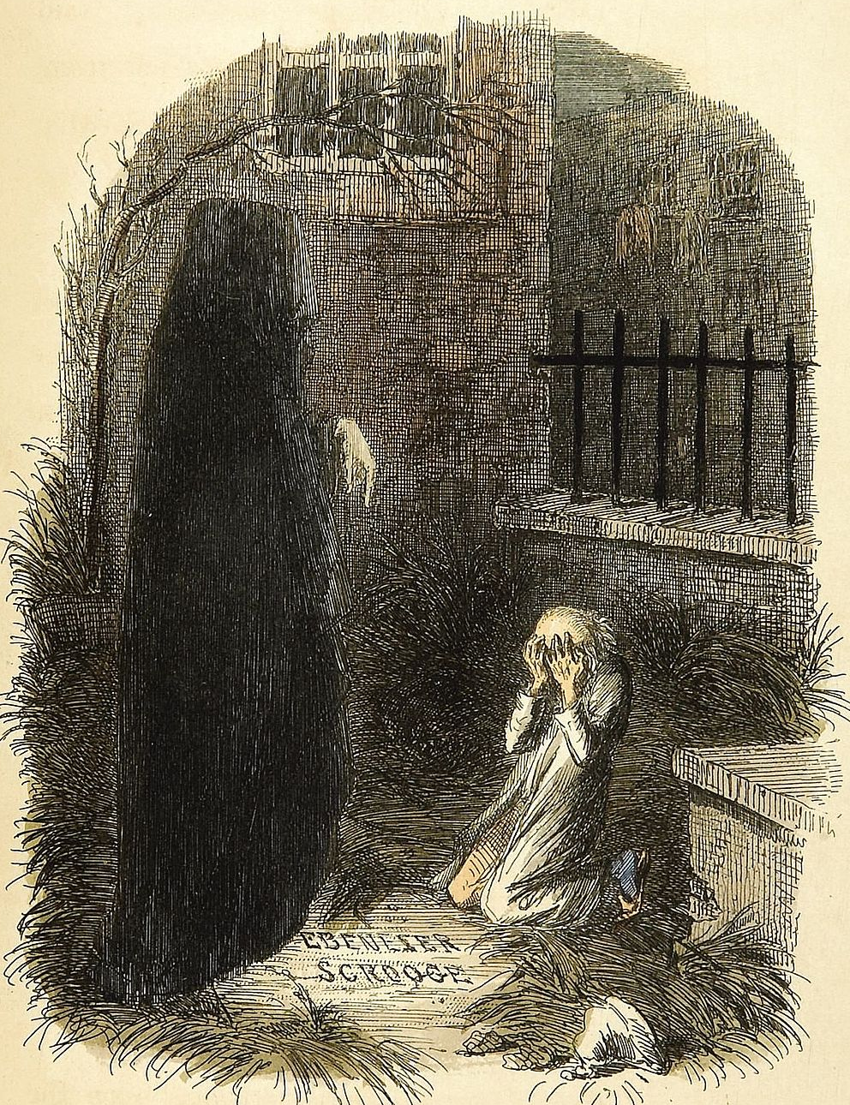
The ghost moved on again, taking Scrooge through the iron gates of a churchyard. The spirit stood among the graves and pointed down to one. Scrooge slowly went towards it, trembling, and following the ghost’s finger read upon the stone of the grave his own name, Ebenezer Scrooge.
“Spirit, that man -who the thieves stole things from- was that man…me?
The phantom stood there. Silence etched on his blank face.
“Spirit!” Scrooge cried, “are these the shadows of the things that will be, or can this future be changed? Hear me! I am not the man I was! I will not be the man I must have been so far! Why show me this if I am past all hope? Good Spirit, I will honour Christmas in my heart, and try to keep it all the year. I will live in the past, the present, and the future. The spirits of all three shall be within me. I will not ignore the lessons that they teach. Oh, tell me that I may change my fate!”
Full of fear, Scrooge caught the spirit’s hand. But the spirit suddenly changed – it shrunk and faded and finally turned into a bedpost.

Chapter 5 – The End of It
Yes! And the bedpost was his own. The bed was his own, the room was his own. Best and happiest of all, the time before him was his own, and he could make the best of it.
“I will live in the past, the present, and the future.” Scrooge repeated, as he got out of bed. “I don’t know what to do! I am as happy as an angel! I don’t know what day of the month it is. I don’t know how long I’ve been among the spirits. Hallo! Hallo there!”
He ran to the window, opened it, and put out his head. He could hear the church bells ringing out several streets away.
“What’s today?” cried Scrooge, calling downward to a boy in Sunday clothes.
“Eh?” returned the boy, confused.
“What’s today, my fine fellow?”
“Today?” replied the boy. “Why, Christmas Day!”
“It’s Christmas Day!” said Scrooge to himself. “I haven’t missed it! The spirits have done it all in one night. They can do anything they like. Of course they can! Hallo, my fine fellow! Do you know the poulterer’s at the corner?”
“I sure do.”
“Excellent boy! And do you know whether they’ve sold the big turkey that was hanging up there?”
“What, the one as big as me?” returned the boy. “It’s still hanging there now.”
“Is it!” said Scrooge. “Go and buy it! I am in earnest. Go and buy it and come back with the man that I may give them the direction where to take it. I’ll give you a shilling for it. Come back with the man in less than five minutes and I’ll give you half-a-crown!”
The boy was off like a shot.
“I’ll send it to Bob Cratchit,” whispered Scrooge cheerfully. “It’s twice the size of Tiny Tim.”.
He dressed himself all in his best and at last got out into the streets. He had not gone far, when he came across the two gentlemen, who had walked into his office the day before.
“My dear Sir,” said Scrooge, “How do you do? I fear I wasn’t pleasant to you yesterday. Allow me to ask your pardon. And will you have the goodness to …”, here Scrooge whispered in his ear.
“Lord bless me!” cried the gentleman, “My dear Mr Scrooge, are you serious? I don’t know what to say to such generosity.”
“If you please,'' said Scrooge. “Not a farthing less. A great many back-payments are included in it, I assure you.”
Scrooge then went to the Christmas service at the church, and walked about the streets, and watched the people hurrying to and fro, and patted children on the head, and questioned beggars, and looked down into the kitchens of houses, and up to the windows: and found that everything could yield him pleasure. He had never dreamed that any walk -- that anything -- could give him so much happiness. In the afternoon he turned his steps towards his nephew's house.
He passed the door a dozen times, before he had the courage to go up and knock. But he made a dash, and did it:
“Fred,” said he implored, “it’s your Uncle Scrooge. I have come to dinner. Will you let me in, Fred?”
Of course, Fred let him in; it was a very hearty welcome and they all had a wonderful party.
But Scrooge was early at the office next morning. Oh, he was early there. If he could only catch Bob Cratchit coming late. And he did it; yes, he did. Bob was full eighteen minutes and a half behind his time. Scrooge sat with his door wide open, that he might see him come in.
“Hallo!” growled Scrooge, in his usual way. “What do you mean by coming here at this time of day?”
“I am very sorry, Sir,” said Bob. “I am behind time.”
“I am not going to stand this sort of thing any longer. And therefore,” he continued, jumping from his stool and poking Bob in the chest, “and therefore I am about to raise your salary. A merry Christmas, Bob.”
Bob Cratchit was very surprised, and so were many people who found Scrooge so changed. Scrooge was better than his word. He did it all, and infinitely more; Scrooge became a better person. To Tiny Tim, who did not die, he was a second father. Scrooge became as good a friend, as good a master, and as good a man, as the good old city knew, or any other good old city or town in the good old world.
He had no further meetings with Spirits, but lived joyfully ever afterwards. It was always said of Scrooge, that he knew how to keep Christmas well. May that be truly said of us, and all of us! And so, as Tiny Tim would say, ‘God bless us, every one!’



