YEAR 6  Term 1: Dr Jekyll and Mr Hyde Usborne series 4  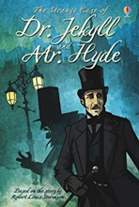 | This Gothic text allows the children to make connections with villains and create predictions based upon the names of Chapters. The mature themes allow children to learn about wills and motives. Children’s vocabulary is challenged and enhanced by this text and the connections with Frankenstein and the contrasts with Clockwork allow for deep and rich discussions. The Children at St Thomas’ benefit from this text as it explores Wills, legal proceedings and criminal justice – making links to British values.
Term 2: Clockwork Phillip Pullman  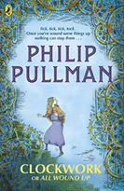 | Clockwork has a lower adventurous vocabulary level but uses a high amount of technical vocabulary. The dark humour, omens and events are exciting for children to explore and the narrator’s out-look on life evokes deep discussions. The themes of the text are suitable to make connections with life choices and consequences. For the children at St Thomas’ they require this text to help them to understand the wider world and the choices people make and their consequences.  *Firework Maker’s daughter.
Term 3: My Secret War Diary  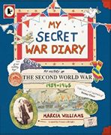 | To support learning in History, this text presents information in a different way that catches the imagination and curiosity of pupils. Information presented in the form of a diary gives a personal insight into life in the War. The layout of the text provides a great model for their own written work and different ways of presenting information.
Term 4 and 5: The Hobbit  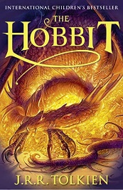 | The Hobbit is a fantasy text that encourages children’s stamina for reading and has a broad and wide reaching range of vocabulary and events that enriches children’s knowledge and understanding of many things outside of our context and setting.  The children experience the reward of reading a larger text and they feel like a more mature reader in readiness for secondary school.  The popular culture aspect also allows children to access the films and to share the text with families as it is an older text. They are also interested in JRR Tolkein and his approach as an author and how fighting in WW1 has impacted the story.
Term 6: Ghost  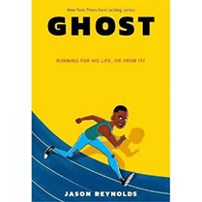 | This text provides great motivation for pupils reaching their goals and thinking about their future as they begin to transition to secondary school. Pupils are able to identify with the characters, their successes and difficulties as they meet the track team. Ghost has been running for the wrong reasons -until he meets Coach, an ex-Olympic Medallist who sees something in Ghost: crazy natural talent. If Ghost can stay on track, literally and figuratively, he could be the best sprinter in the city.

YEAR 5  Term 1: Lighthouse  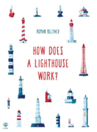 | This book, complete with illustrations is a great start to explanation texts, exploring how information can be presented in different ways. With a familiar starting point of a school trip, pupils can identify with the context and see the different way illustrations, facts and information are presented as models for their own explanations.
Term 2: The Boy at the Back of the Class  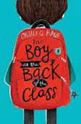 | This text delicately explores the life of refugees coming to Britain, something that is often in the press. Children can draw connections to their own life experiences as pupils coming to our school from other countries or as Bostonians accepting pupils from other countries. It supports the development of understanding and empathy for pupils in those circumstances. With a familiar setting of a school, all pupils are able to identify with elements of this book. A super novel that leads many pupils to read further work by the same author.
Term 3: The Explorer  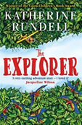 | This longer text allows children to establish stamina for reading over a longer period. The children are able to access the characters and to dig deeper into the themes because of where this text sits in relation to the curriculum in Geography that teaches our children about the Americas. This year, Year 5 were lucky enough to visit Lincoln to hear Katherine Rundell speak about her newer books but also hear about her adventures and inspiration for writing this book.
Term 4: Cogheart  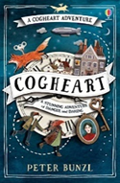 | Cogheart by Peter Bunzl continues to build stamina for reading with our pupils. It is a fantastic tale of murder, mayhem and mystery set against the backdrop of a reimagined, Victorian London. Packed full of vibrant characters, weird and wonderful steampunk creations and a menacing world that jumps off the page.
Term 5: A visitors guide to ancient Greece- Usborne  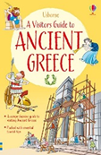 | Links to History learning about Ancient Greece, this book uses facts and non-fiction to give further information about life at the time. It provides another example of how information can be presented on the page to engage the reader as models for their own writing. Developing knowledge and vocabulary, the book supports further learning in the curriculum for our pupils.
Term 6: Letters from the Lighthouse  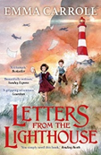 | This text, set in World War 2 in the UK, gives pupils an insight into life at the time. The great adventure and mystery surrounding the disappearance of her sister gives children a great hook to keep them reading until the end.  It follows the secret of Olive and how she searches for her older sister Sukie who went missing in an air raid. She finds a strange coded note which seems to link Sukie to Devon, and to something dark and impossibly dangerous. Written by Emma Carroll, it is a great springboard for reading other novels by her.  Great vocabulary used in context to further support learning about life in World War Two when pupils are in Year 6.

Year 4  Term 1:  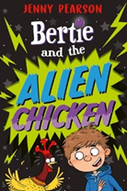 | This humorous text excites and entertains pupils. With a familiar setting and characters that are easy to understand and engage with. Bertie is NOT looking forward to spending the summer holidays on stinky Long Bottom Farm. But things take an interesting turn when he encounters Nugget, the alien chicken. Nugget’s mission is to find the Earth’s most important resource and transport it back to Nurgle 7, and he needs Bertie’s help. But what could the Earth’s most valuable resource be, and can they find it in time to stop the Nurgles exterminating the Earth?!
Term 2: | A first look at work by Michael Morpurgo, children can make connections between life now and in the past comparing their homelife to that of a contrasting locality and island life. Looking at the development of friendship between the character, the sequence of events and how they are interlinked to support story planning and writing. Use of inverted commas is clearly modelled to reinforce correct use of punctuation in their own work.
Term 3:  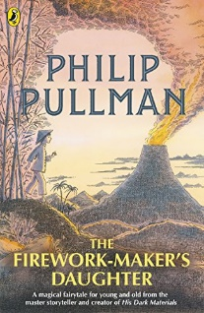 | Exploring the development of characters within the book. Children explore vocabulary, key sequence of events and their impact on one another. Links to clockwork in year 6 looking at texts by the same author. A great adventure story of a brave young girl called Lila who has to go on an exciting adventure to fulfil her dream of becoming a Firework-Maker like her father. It also includes lots of humour alongside this journey through a country very different to our local area.
Term 4:  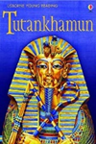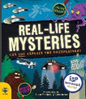 | These non-fiction texts explore some of the great mysteries of the world, enabling children to ask and answer their own questions as they read. Introduction of vocabulary is exciting and the illustrations make the book accessible to all. A mixture of paragraphs and quick facts give pupils models for presenting their own written work across the curriculum.
Term 5: | This text supports pupils building confidence in reading stamina as they engage in this adventure which supports further learning across the curriculum. When Lilian Kaye finds a parcel on her grandad's doorstep, she is shocked to see who sent it: a famous Egyptologist, found dead that very morning, according to every newspaper in England!  Pupils will read other texts by Emma Carroll in Year 5.
Term 6:  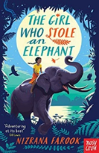 | Pupils are introduced to this adventure story, exploring new settings and characters that they can compare to others read about over the year. Chaya, a no-nonsense, outspoken hero, leads her friends and a gorgeous elephant on a noisy, fraught, joyous adventure through the jungle where revolution is stirring and leeches lurk. Will stealing the queen’s jewels be the beginning or the end of everything for the intrepid gang?

Year 3  Term 1:  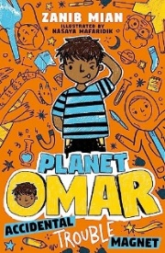 | This book is chosen for the fun it brings to pupils who will have great fun on planet Omar! Our hero's tales of everyday life with his family and at school give pupils a familiar setting and day to day life. The book also offers insight into the life of an ordinary Muslim family, which supports pupils knowledge and understanding in RE as the book supports to counter negative stereotypes of Muslims.
Term 2: | Exploring the different characters within this book, it also supports our learning in PSHE on relationships and bullying. The relationships of Ruskin with each character is explored along with those of his parents in the past. Investigating the story of Lizard Street and the terrifying Krindlekrax makes for an exciting adventure story.
Term 3:  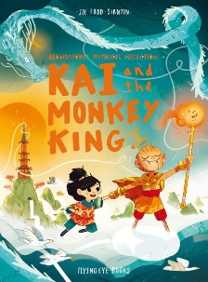 | This graphic novel is a great springboard to use before studying Arthur and the Golden Rope for writing in Year 4. Exciting vocabulary captures the pupil’s imagination and draws them into the adventure. Use of illustrations make it accessible to all pupils, engaging and exciting.
Term 4:  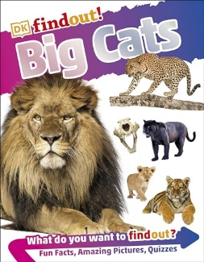 | This text uses real photographs to explore key facts about Big cats. Linking to learning about animals in other areas of the curriculum, this book gives great information for further study of animals including humans in science providing pre-teaching of information about diets and food chains. Pupils can see how questions are asked and answered in this text to provide models for their own non-chronological report writing, exploring the use of paragraphs and technical vocabulary.
Term 5:  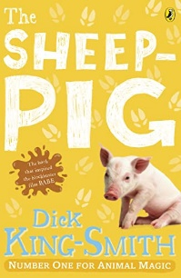 | Introduction to Dick King Smith and his tales about animals that may inspire children to read more. Familiar setting of a farm for children to make connections to along with knowledge of the local area.
Term 6:  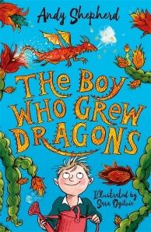 | A great adventure story that inspires pupils to read further books in the series. When Tomas discovers a strange old tree at the bottom of his grandad's garden, he doesn't think much of it. But he takes the funny fruit back into the house - and gets the delight of his life when a tiny dragon hatches! Tomas has to learn how to look after Flicker - quickly. And then something extraordinary happens - more dragonfruits appear on the tree. Tomas is officially growing dragons!

YEAR 2  Term 1:  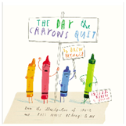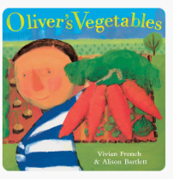 | These texts provide familiar characters, settings and events as they begin to read with further fluency, comprehension and understanding of texts. Continuing to build sight vocabulary to read with automaticity. The Day the Crayons Quit is a great back to school read and Oliver’s Vegetables supports further curriculum learning about Harvest and growing.
Term 2:  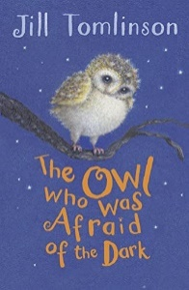 | First introduction to a longer text, chapter book exploring the theme of dark, something familiar to the children.  Pupils explore character description, settings and the sequence of events in each short chapter which comforts them into knowing how the dark can be positive.
Term 3: | Introduction to non-fiction text using an atlas of the world. Use of contents page and index. Images of maps, animals and people, opens up the world for pupils to ask questions and explore. Children use the set out of non-fiction and identify key features like titles, labels, images and captions.  Pablo and Splash allows pupils to dive into the world of Graphic Novels and the humour they often bring.
Term 4:  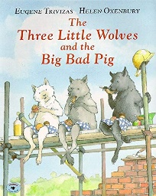 | The use of an alternative fairy tale supports pupils to challenge stereotypes and explore characters within texts and how they are portrayed.  Up in the Garden and Down in the Dirt, embeds knowledge in Science about plants and growing in a different way through the use of wonderful vocabulary.
Term 5:  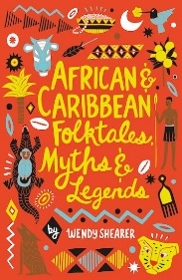 | Exploring texts from different cultures through the story of Anansi and the tales associated with him. Anansi stories, which originated in Ghana, teach children morals about the consequences of bad choices, the importance of humility, and the value of sharing, which embed their understanding of themes taught in our PSHE curriculum.
Term 6:  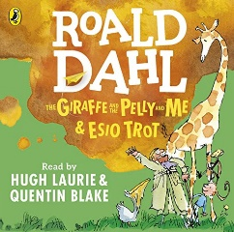 | Introduction to literary great Roald Dahl, children can explore the longer text. Engage in the imaginary world of Roald Dahl and explore characters alongside rhyming verse.

YEAR 1
Term 1:

Term 2:

Term 3: | These core texts are a great way into whole class reading for year 1 with their repetitive lines that all pupils can join in with. Focussing on intonation, expression and the dramatization of texts, these books give a great structure for their own writing along with lots of opportunities for drama and visualisation activities. They build up fluency through the repeated reading of high frequency words and red words from RWInc phonics teaching.  They include familiar characters and settings that children can make connections to other familiar stories.
Term 4: | Links are made to other texts by Julia Donaldson, retrieving and retelling stories they have already heard like The Gruffalo whilst joining in with this repetitive text. Repeated reading of the text builds fluency and comprehension of the test with familiar characters and setting. Children are able to join in with the animal sounds from the first reading drawing on their prior knowledge of animals.
Term 5:  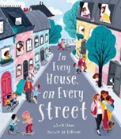 | Complimenting our PSHE curriculum, this book allows children to explore the theme of families and relationships and their differences.
Term 6: | Links are made to other texts by Julia Donaldson, retrieving and retelling stories they have already heard. Children are able to join in with the animal sounds from the first reading drawing on their prior knowledge of animals and their visit to the farm.  The Adventures of the Dish and the Spoon. This text by Mini Grey builds upon the knowledge of nursery rhymes and has links to Traction Man which is part of our English curriculum. The book supports vocabulary development along with exploring different characters.

