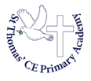


Autumn Term
in Reception
‘The LORD gives strength to his people; the LORD blesses his people with peace.’
(Psalm 29:11)

Welcome! We would like to begin by taking this opportunity to welcome all of our parents/carers to the first term at Saint Thomas' Primary Academy. We hope you have had a fantastic summer and made lots of memories with your family and friends. We are excited to officially meet our new classes and begin lots of exciting learning. This is the beginning of their school journey and we can’t wait to see how the children flourish and reach their full potential.
The Early Years Team would like to take this opportunity to thank all the Reception parents and carers for their cooperation and support during the start of this term. We would also like to say a big `Well Done` to all the children who have settled in extremely quickly. Thank you for all the parents that also managed to attend the parent transition meetings, it was a pleasure to meet so many of you.

PE KIT must be in school on Wednesday.
Jewellery must not be worn, this includes earrings.
Long hair must be tied back.
All PE kit and uniform must be labelled with your child’s full name.

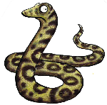
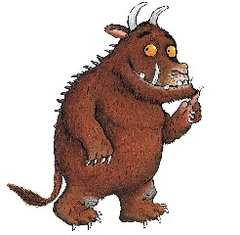
Reading Books – To start, all the children will bring home a story book with a sticker that reads `Reading for Enjoyment`. These books are to be enjoyed at home with an adult reading the story to encourage children to listen to new vocabulary and explore a range of genres. Please ask your children questions about what they have read to develop their comprehension skills and love for reading. Below are our `Top Tips` for reading with your child at home.

Top Tips for Reading with your Child
- Set aside some time-Find somewhere quiet without any distractions - turn off the TV/radio/computer.
- Ask your child to choose a book-Sharing books they have chosen shows you care what they think and that their opinion matters. This means they are more likely to engage with the book.
- Sit close together- Encourage your child to hold the book themselves and/or turn the pages.
- Point to the pictures -If there are illustrations, relate them to something your child knows. Ask them to describe the characters or situation or what will happen next. Encourage them to tell you the story by looking at the pictures.
- Encourage your child to talk about the book-Talking about the characters and their dilemmas helps children understand relationships and is an excellent way for you to get to know each other or discuss difficult issues. Give your child plenty of time to respond. Ask them what will happen next, how a character might be feeling or how the book makes them feel.
- And lastly, above all - make it fun! It doesn't matter how you read with a child, as long as you both enjoy the time together. Don't be afraid to use funny voices - children love this!

We encourage you to read these stories more than once to inspire your child to join in with key phrases and develop their story telling skills. These books will be changed on a Friday.
Throughout the beginning of the term, the children will also be sent home with QR codes where they can take part in phonics session at home. The sound that has been taught in school can then be revisited at home the same evening. They will also bring home a handwriting sheet which focuses on the same sound. Once the children have started to read simple words independently, they will then bring home a phonics book which will be changed on a Tuesday and Thursday. If you have any questions regarding reading and phonics, please speak to a member of the EYFS team.
You can scan the QR codes below or use the links to find more information about how you can support your child at home with their reading.
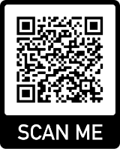
www.readingrockets.org/article/tips-encouraging-kids-read


www.verywell.com/activities-to-encourage-pre-reading-621060

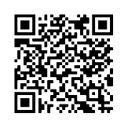
https://www.booktrust.org.uk/books-and-reading/tips-and-advice/

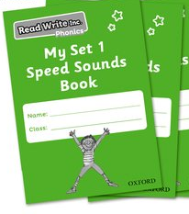
Homework – The children this term will take home the booklet: `My Set 1 Speed Sound Book`. These booklets are to support the children with learning their set 1 sounds and practise the correct letter formation. Each day, the children will learn a new sound which they can practise at home. The sounds being taught can be found on the QR codes that will be sent home.

Children may also be sent home with a homework book. These will be sent home on Friday and will contain Maths or Literacy tasks. These tasks will need to be returned by the following Wednesday. Some homework tasks may be set using our online journal- Tapestry. More information about this will be sent this term. Some terms we may send home a homework project for the children to complete over the term, however we will send lots of information regarding this nearer the time.


Snack time - Water bottles and snacks should be labelled where appropriate; children will bring these into the classroom in the morning and place them in a basket. Drinks should all be in a bottle which has a sports lid and they are only allowed water in these. We would like to remind parents free snacks are available to all children, however if you wish to pack a snack for your child, we encourage healthy, to promote a healthy and balanced diet.

Other notices- Please remember children need to be dropped off and collected at the Reception doors and the doors will be closed at 8:45am in the morning. They will be opened at 3:15pm in the afternoon. Children will only be dismissed to their parent/carers. We ask that if somebody new is collecting that you let the class teacher know and the main office. Only adults 18 and over are able to collect children from school.
Please do not allow your child to play in the Reception outdoor areas or climbing equipment before or after school- please do not allow your children to stand on the table tennis tables on the KS2 playground or use the KS2 Adventure Playground equipment.
If possible, please provide wellington boots (named) so your child can access our fantastic outdoor area. Children can also be sent into school with additional outdoor clothing if you prefer, however we do have some all in one suits available that they can use.

Meet the Reception Team:
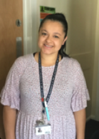
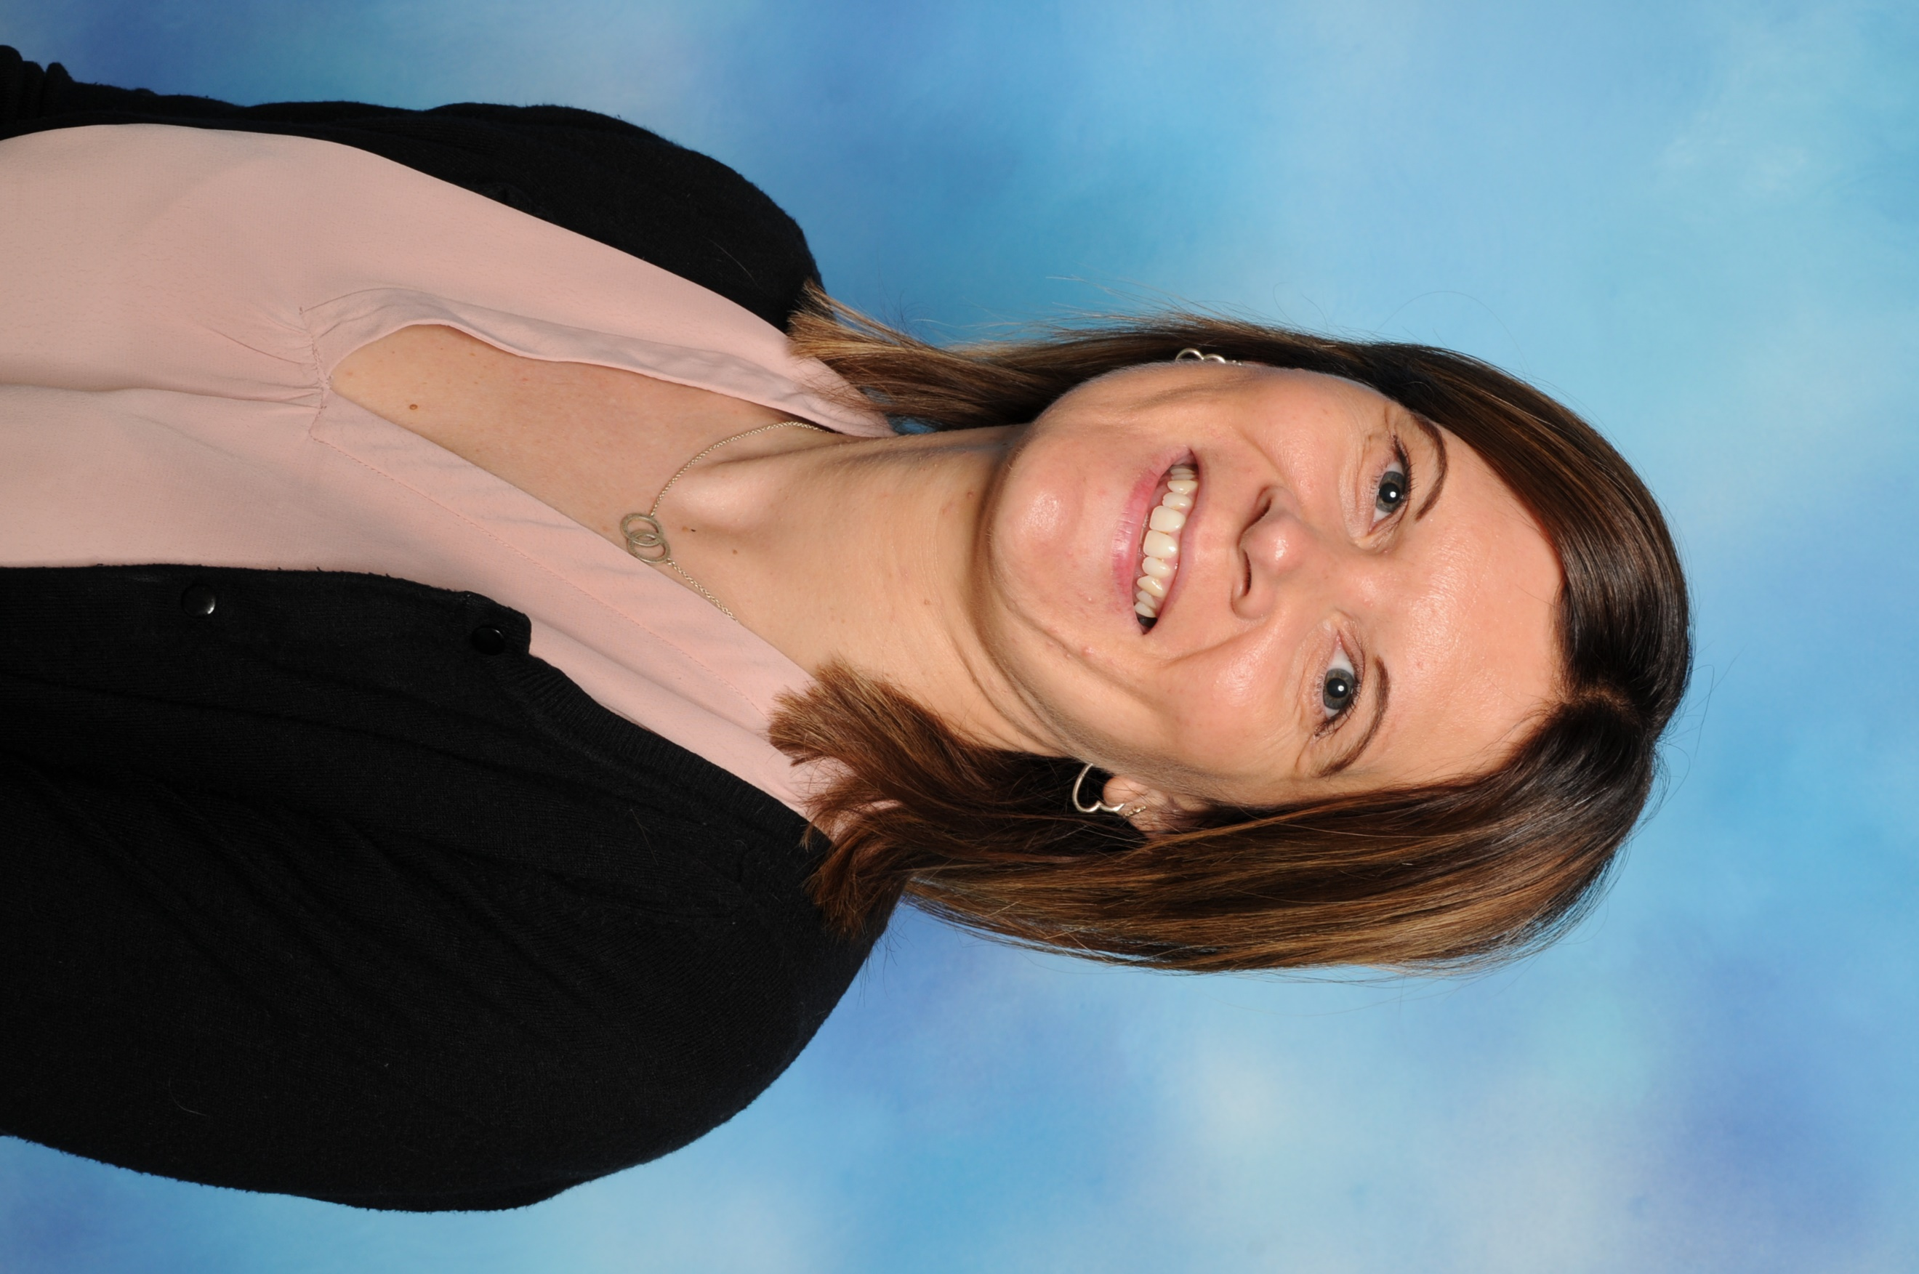
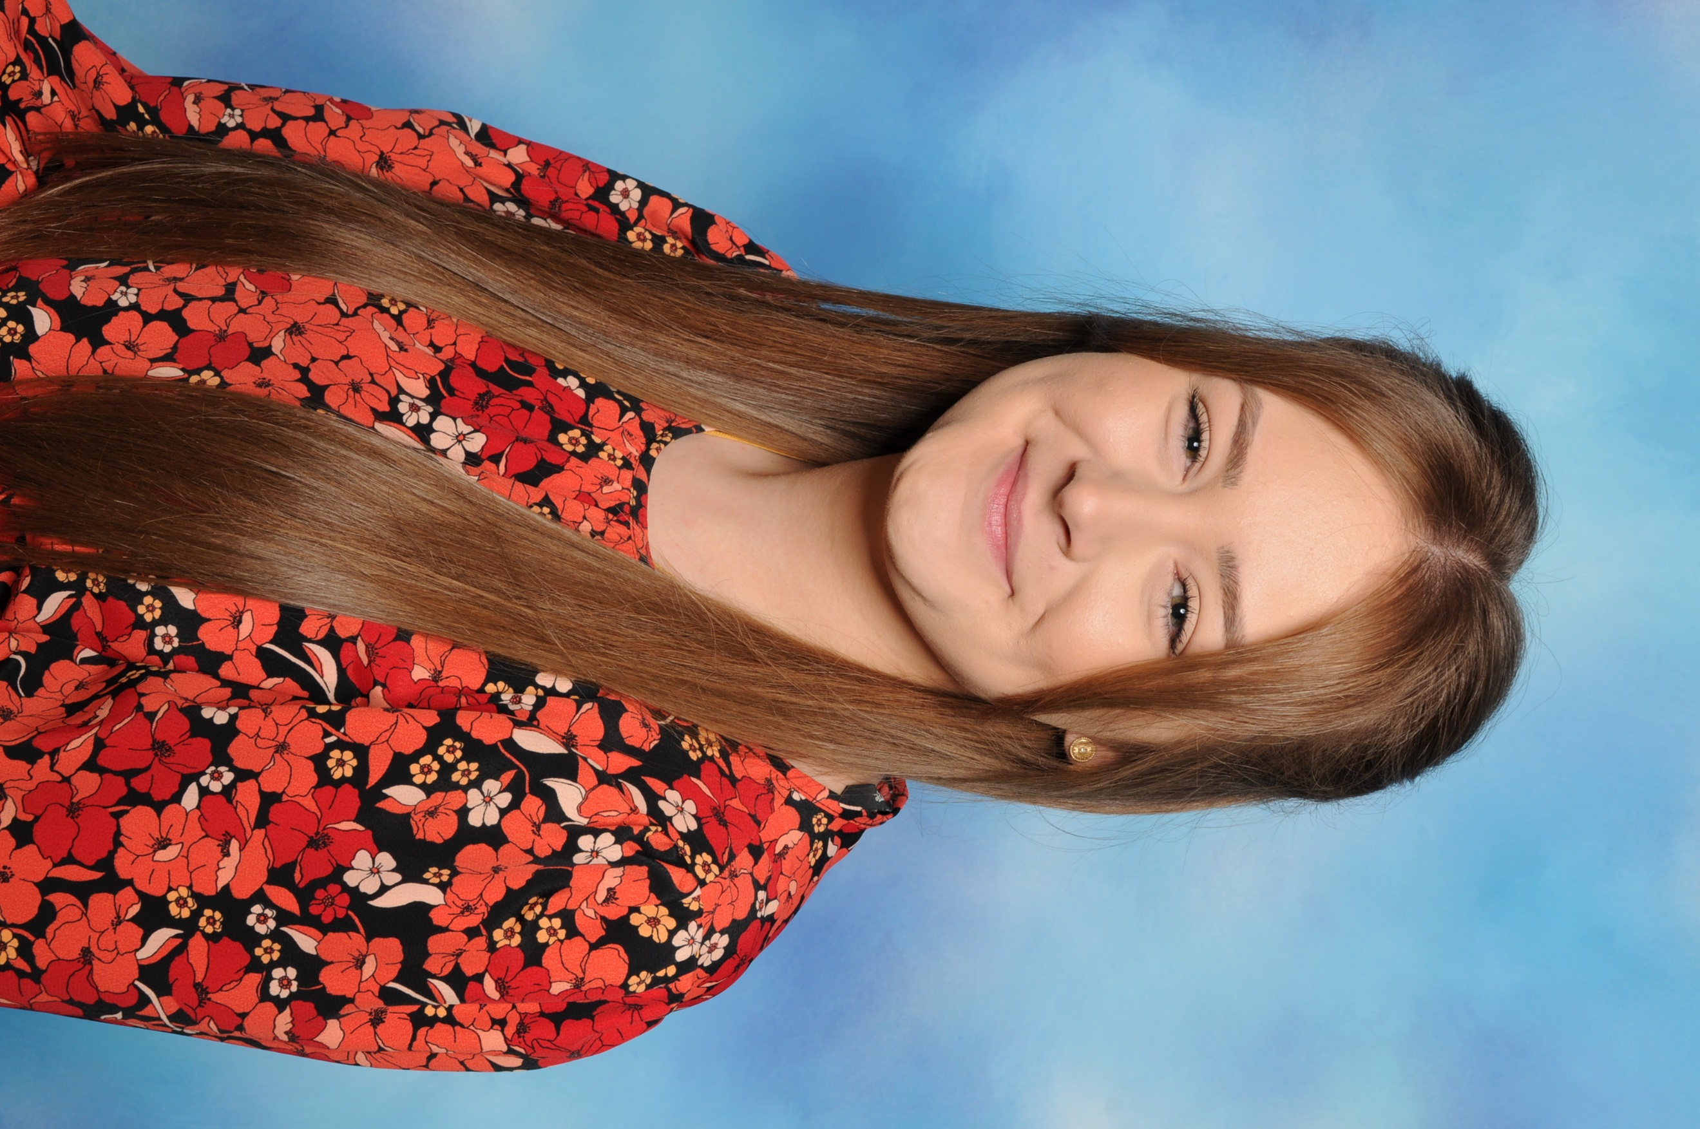


Miss Lenton Miss Williams Miss Lucas Mrs Fraser
RL Class Teacher RW Class Teacher RL Teaching RW Teaching
Assistant Assistant

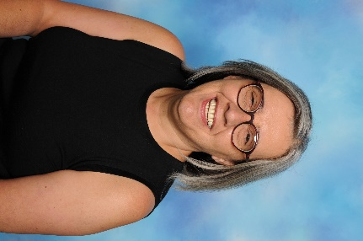
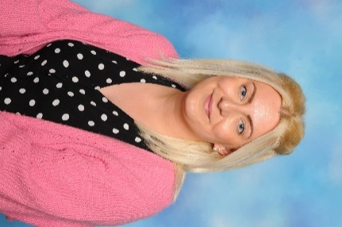

Miss Brittain Mrs Ford
Language Teaching Assistant Teaching Assistant
Our Curriculum: our EYFS curriculum has been tailored to support your child’s learning and development. There will be 6 topics throughout the year, which will have linked stories, rhymes and songs that the children’s learning will link to. These topics will be shared with you on our class web pages, Tapestry, Twitter and our termly newsletters. Children’s interests are always at the heart of our curriculum and this is something we ensure we follow to support their love of learning.
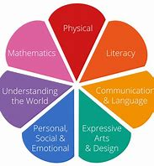
The EYFS curriculum focuses around the seven areas of learning. These are:
- Communication and Language
- Personal, Social and Emotional Development
- Physical Development
- Literacy
- Mathematics
- Understanding the World
- Expressive Arts and Design
The children will still learn through play and adults will facilitate their learning through modelled play, conversations and interactions with other children. If you would like any information regarding our curriculum and the framework, please speak to your child’s class teacher.

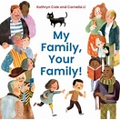
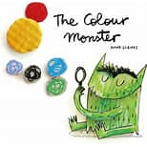
What will we be learning about?
Topic for Term 1: It’s good to be me!
Our topic for this term is to find out about all of the children and their interests. The children will learn about families and the likes and dislikes of others. They will also have the opportunity to explore the Autumn season whilst settling into school. All our themes will focus around a story.
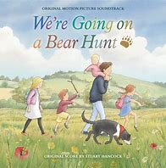
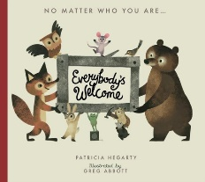

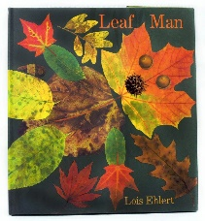
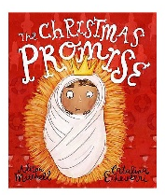
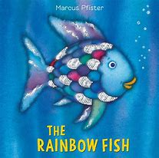
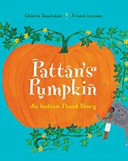
Topic for Term 2: It’s good to be you!
This term we will be learning about others and why it is important to be special and unique but also be tolerant and accepting of others. During this term, the children will also explore different celebrations including Bonfire Night, Diwali and Christmas.
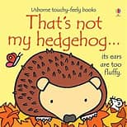
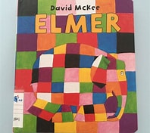
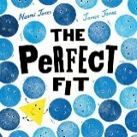

The structure of our day at school:
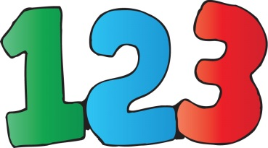
During Term 1 and 2 the day will consist of very short, sharp bursts of whole class, adult-led learning time, adult directed choosing and independent learning. Behaviour and routines will also be a focus this term, as we will be encouraging children to sit on the carpet with their legs crossed and take part in lots of listening and attention activities. We appreciate all the parents support with this, as it will ensure all children progress effectively with their learning. Self-regulation will be a continuous focus throughout the year to develop the children’s understanding of their emotions but also support them to concentrate on their thinking, focus their attention and develop their language and vocabulary to help guide their actions and plans.

The children this year will be taking part in the Lincolnshire Smile program. This program is a way to promote and develop positive oral health skills. Please ensure you have filled out the permissions slips if you would like your child to take part.
Reception Baseline Assessment-
This year all children in Reception will take part in the EYFS Baseline Assessment, which is a statutory Government assessment. All assessments will be administered throughout the first 6 weeks and in a child friendly way by a familiar adult. All children will take part in a range of practical activities and although it is an assessment, you do not need to be concerned about this. If you have any questions about the assessment, please speak to your child’s class teacher.

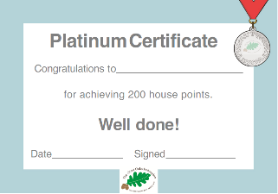
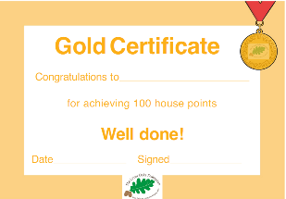
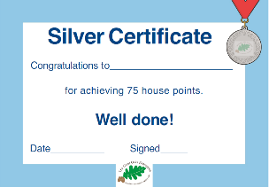
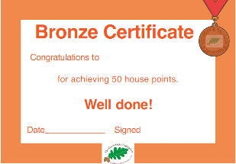
House Points- Throughout the year, Reception will be awarded with house points for their exemplary behaviour, demonstrating our Church School Values, showing resilience and determination when completing their work, displaying wonderful manners, reading at home and being excellent role models. When the children have reached their target each term, they will be able to choose their own class treat. This could include watching a film, taking part in a cooking activity or a visit or trip. The choices are endless. They will also be awarded a certificate which will be handed out during our Celebration Worships. Below are some of the certificates your child may receive throughout the year.
E-Safety- Safety is very important to us and your children, so they will be learning how to keep themselves safe throughout the curriculum, through our safety days and curriculum weeks. The internet is such an amazing resource, but children must know how to use it safely. We ask for your support with teaching your child to use websites and apps safely at home too.
______________________________________________________________________________________________
Please keep up to date following us on twitter:


@MissLenton2
@infintyAcad
@StThomasBoston
________________________________________________________________________________
To keep up to date with our class website pages:
www.stthomasacademy.co.uk
Children
Class pages
Joy class(Miss Lenton)
Love class (Miss Williams)
_______________________________________________________________________________
Thank you for your support. If you wish to ask any questions to any member of our Early Years Team, please feel free to ask.
Miss Lenton and Miss Williams

