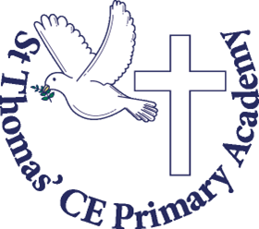

Spring Term
in Year 1

Welcome back!
We really hope that everybody had a lovely Christmas with your families. We have enjoyed hearing about your adventures over the Christmas holidays.

We are very proud of how well the children have settled back into school routines after the Christmas break. The school’s website will continue to be regularly updated with pictures of the children enjoying their school day.

Homework - Homework is important and we will expect it to be completed and handed in on time. It helps consolidate learning and build up your child’s confidence. This term, it will be weekly English and Maths activities including EdShed, which will be given out in homework books on a Friday to be completed and handed in on a Wednesday. As always children can earn house points for completing their homework.

Reading Books – These need to be in school daily. The children will receive a book matched to their phonetic ability which will be changed weekly depending on which phonics group they are in. This is expected to be in school throughout the week. The children will also receive a Reading for Pleasure book to share with adults at home on a Friday.
Please ensure books are returned to school.
Spellings – These will be set on a Friday and tested on a
Friday. We advise they use a Look, Cover, Check approach mixed in with chanting as this makes it more exciting. The words we will be learning this term are a mix of key subject vocabulary, the year 1 common exception words and words which the children use in their phonics lessons.
PE- A quick reminder that earrings need to be removed or covered on P.E days (in line with the school’s policy). This term PE is on a Tuesday and Friday. Please ensure your child has the correct PE kit in school each week, this should be clearly labelled with your child’s name.
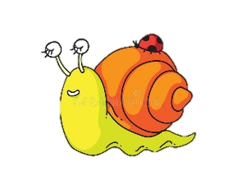
PSHE - Much of this is discussed during our reflection times, in which children are given the opportunity to share thoughts and feelings whilst listening to others. We also link these concepts to our overall subjects, providing a real context to build relationships with people and the feelings that this can bring.

Our big questions this term:
RE - What do Muslims believe Allah is like?
Art – Why is line important?
Geography – How is our town special?
Science – Are we all the same or are we all different?
PSHE – Is everyone special?
PE – Why is counting important in dance?
How will co-ordination help improve accuracy?
Computing – Are instructions important?

Science- Are we all the same or are we all different?
Do all animals have the same senses as humans?
Working as a biologist- to study the life of animals and humans, we will be looking at the different animal groups and the different types of diets that animals have. We will also be making careful observations of animals and each other so that the children can identify and describe observable differences, naming parts of the body and features correctly.

English Skills
This term we focus on writing to inform as we write instructions for making a bug hotel and a pirate hat. The children will also be using the texts ‘Look Up’, ‘Ravi’s Roar’ and ‘Little Red Riding Hood’. Our focus will be on a character’s thoughts and feelings, retrieving knowledge from our PSHE lessons.
Art- Why is line important.
This term we explore the artworks: A line going for a walk by Paul Klee, Animals by Pablo Picasso, Elephant by David Shrigley. This will help us learn about the different style of lines.

Year One Spring Term Overview
Geography-
How is our town special?
Children will understand the vocabulary of human and physical geography and they can identify some of these features in the local area. They will apply this understanding to make comparisons between two environments (urban/town, rural/woodland). Children will notice the impact of seasonal weather on these environments.
Computing - Are instructions important?
Our focus is on coding where we will explore Beebots and the different commands they can be given. We will then begin to create our own program and investigate the ways we can debug it.

Mathematics
We will begin the term by exploring the place value of numbers up to 20. This will include finding one more and one less. This then leads into finding doubles and number bonds to 20. Finally we move on to adding and subtracting numbers to 20.

R.E - What do Muslims believe Allah is like? (God)
In our Islam unit, we will be exploring what it means to be a Muslim through artefacts and a story sack. This will then lead us into learning about how Muslims live in harmony,

P.E.
Dance - Why is counting important in Dance?
Target Games – How will coordination help improve accuracy?
This term we will have target games on a Tuesday and dance on a Friday.
PSHE – Is everyone special?
With a focus on Health and Wellbeing this term the children will draw upon opportunities and experiences to aspire to achieve and maintain a healthy and balanced lifestyle.

Children will learn how to express, understand and control their own emotions through self-regulation.

Children will have the knowledge to manage risk with a clear understanding of safe and unsafe environments and situations.

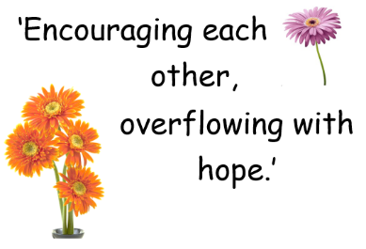

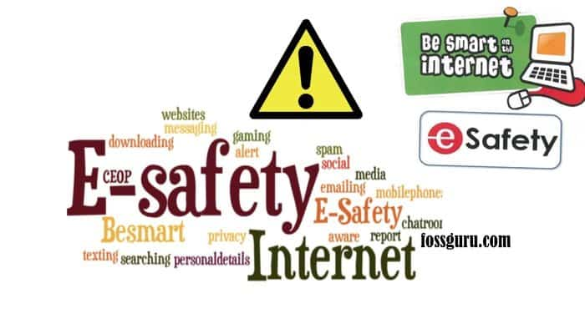
Important website links and E-safety:
https://www.nspcc.org.uk/preventing-abuse/keeping-children-safe/online-safety/
https://www.saferinternet.org.uk/advice-centre/parents-and-carers
https://www.thinkuknow.co.uk/parents/
https://www.stthomasacademy.co.uk/
https://www.stthomasacademy.co.uk/year-one-gentleness-class/
https://www.stthomasacademy.co.uk/year-one-kindness-class/
https://st-thomas-cofe-boston.primarysite.media/

We are so excited to continue to inspire and support your children in reaching their potential this year with your valued support across the curriculum.
PE KIT must be in school on the following days:
Jewellery must not be worn and long hair tied back.

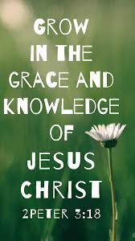
Please do speak to us if you have ideas, questions or concerns over your child. Remember to inform us of any change in circumstance – little or big. It can really affect the behaviour and feelings of your child and we want to be able to support your child as fully as possible.
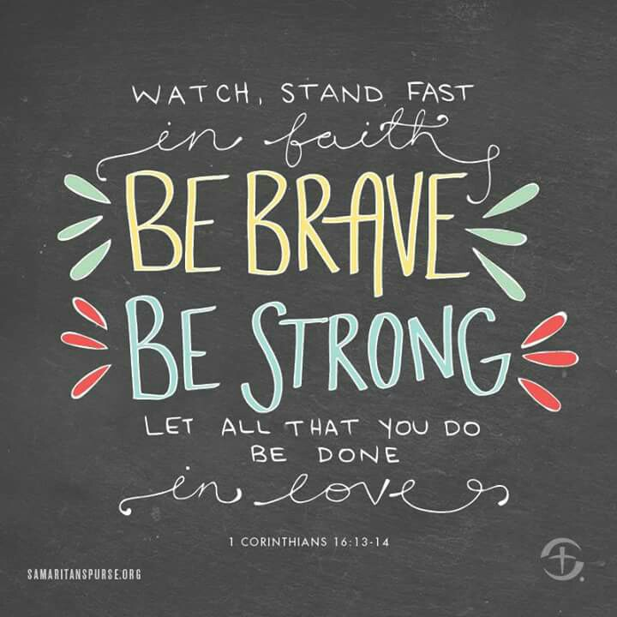
Year 1 team

