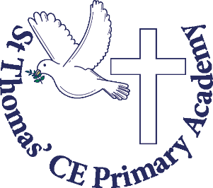
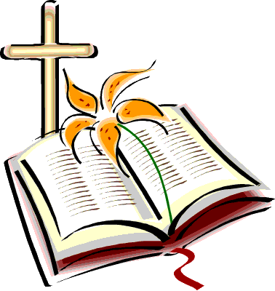
Autumn Term
in Year 2
“This is the day the LORD has made, let us rejoice and be glad in it,” Palms 118:24
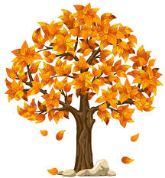
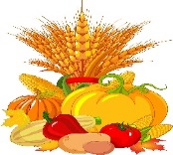
Welcome back! We hope you were able to enjoy the sunshine and had a relaxing summer break spending lots of time with family and friends. We are very excited to be working alongside yourself and your children in the exciting challenges ahead. Year Two is an important year for the children as they transfer and apply all the useful skills they were provided and taught within Reception and Year 1 and start to become more fluent and secure in their knowledge. Through their endurance skills - they will continue to build up their spelling and grammar knowledge, as well as progress with times tables and mental arithmetic.
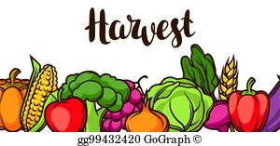

This term, we will be focussing lots of our learning around ‘Harvest’. This will allow the children to explore the importance of the Harvest festival in the UK but also learn how it is celebrated around the world. Each subject will be taught separately and there is a big question for each unit. We will investigate how plants and vegetables grow, the perfect conditions needed to produce successful crops, how the harvest supports our local community and links to our church values. In Art, we will be focusing on the skill of painting and creating our own Harvest pictures. Also, this term, we will be practicing for the Harvest Festival, which we will be performing at school and at the local church.

PE Kit must be in school every day
Jewellery must not be worn, this includes earrings and long hair must be tied back.
All your child’s kit must be labelled with their full name. This makes it easier for staff to find any misplaced clothing.

Physical Education- This term your child will take part in weekly PE lessons, which will include fitness and team building games. Encouraging your child to stay active will support your child’s emotional, physical and academic development. If you would like any ideas on how to keep your child active outside school then please use the links below.
https://www.bbc.co.uk/sport/get-inspired
https://www.nhs.uk/change4life

“The more that you read, the more things you will know. The more you learn, the more places you’ll go.”— Dr. Seuss.


Reading Books – These need to be in school daily. New books will then be given out on a Tuesday and a Friday. If you would like to support your child with their reading at home, below is a link of a range of stories that your child might enjoy and some questions which will develop your child’s comprehension skills.
https://www.booktrust.org.uk/booklists/1/100-best-books-6-8/
Oxford Owl – The children all now have a login for the Oxford Owl website, which includes a phonics reading book from the E-Library and a quiz linked to the story. This will be set weekly so please support your child with completing this. Their login for this is in their Reading Record.

Class Novels- Each day your child will take part in a story time session where the teacher will read a class novel. Below are the stories that your child’s class teacher will be reading with the class this term. You can also find a list of stories that you may wish to read with your child at home.
2R-George’s Marvellous Medicine by Roald Dahl
2F- The Twits by Roald Dahl

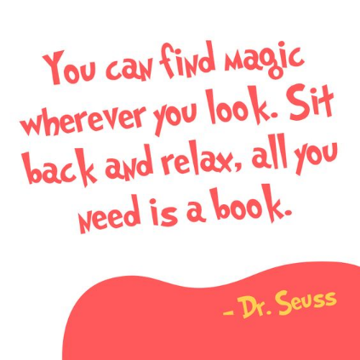
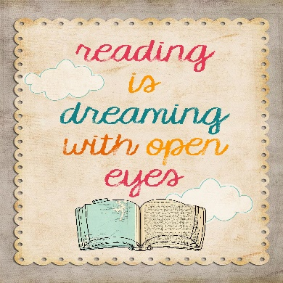

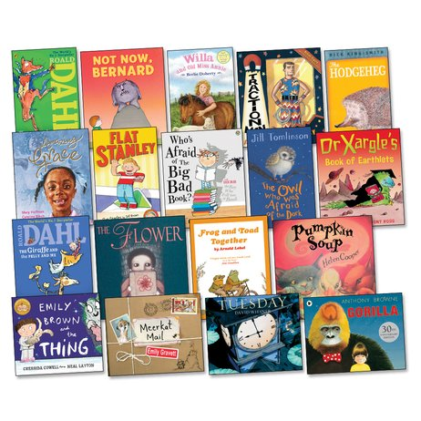
Recommended Reads for Year 2
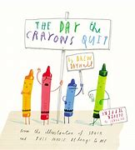

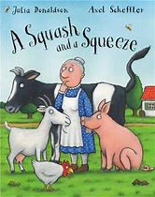

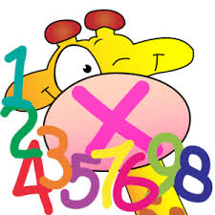
Spellings – These will be set on a Friday and tested on a Friday. I advise they use a Look, Cover, approach mixed in with chanting. This makes it more exciting.
Times tables- These will be learnt and tested throughout the term. They will need to be able to know them all ways, i.e 4x2=8, 2 x 4=8, 8=4x2 and 4 2s are 8. They will be quizzed in this way.
E-safety
Safety is very important to us and your children, so they will be learning how to keep themselves safe throughout the curriculum, through our safety days and curriculum weeks. The internet is such an amazing resource, but children must know how to use it safely. We ask for your support with teaching your child to use websites and apps safely at home too.

This is the final year of the Key Stage One curriculum for your child. In May your child will participate in Government tests called KS1 SATs. There will be more information about these later in the year and please do not be concerned about these.
Please keep up to date following us on twitter and our class pages on the website.

@MsFerguson36
@MrsRichardsonTe
Big Questions:

Religious Education – Do you only have to day thank you if you believe in God?
We will be exploring how Christians give thanks and celebrate Harvest Festival.
History – Is one person able to change the world?
We will be learning about Florence Nightingale and Mary Seacole.
Geography – Is the climate important?
We will look at the difference between physical and human features, as well as how the landscape changes through the seasons.
Science – What creates a healthy plant?
We will be exploring what helps a plant to grow successfully.
PSHE – Are surprises and secrets the same?
In PSHE, we will be looking at relationships with friends.
Music – Who is more important: the singers or the audience?
We will be learning to sing songs for our Harvest Festival performance.
Art – How does colour change a painting?
We will be exploring tertiary colours and creating art for harvest.
Computing – How do we keep our personal information private?
We will be looking at the importance of online safety and keeping our personal information private.
PE – How will working together help our mental health?
What do you notice about your breathing when exercising?

House points:
Throughout the school day the children can earn House points for things like demonstrating the schools core values, reading at home, completing homework and participating in lessons. Children will then in return receive bronze, silver and gold certificates and at the end of each term, the children can choose a reward that they would like to do: for example, art afternoon, cooking etc.

Meet the Year 2 Team
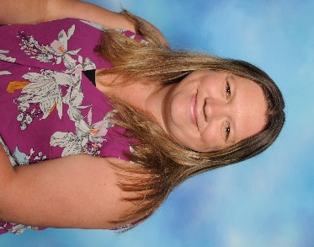
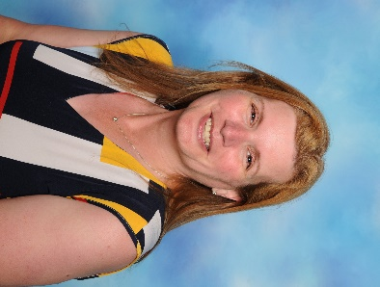

Miss Ferguson Miss Richardson
2F Class teacher, 2R class teacher
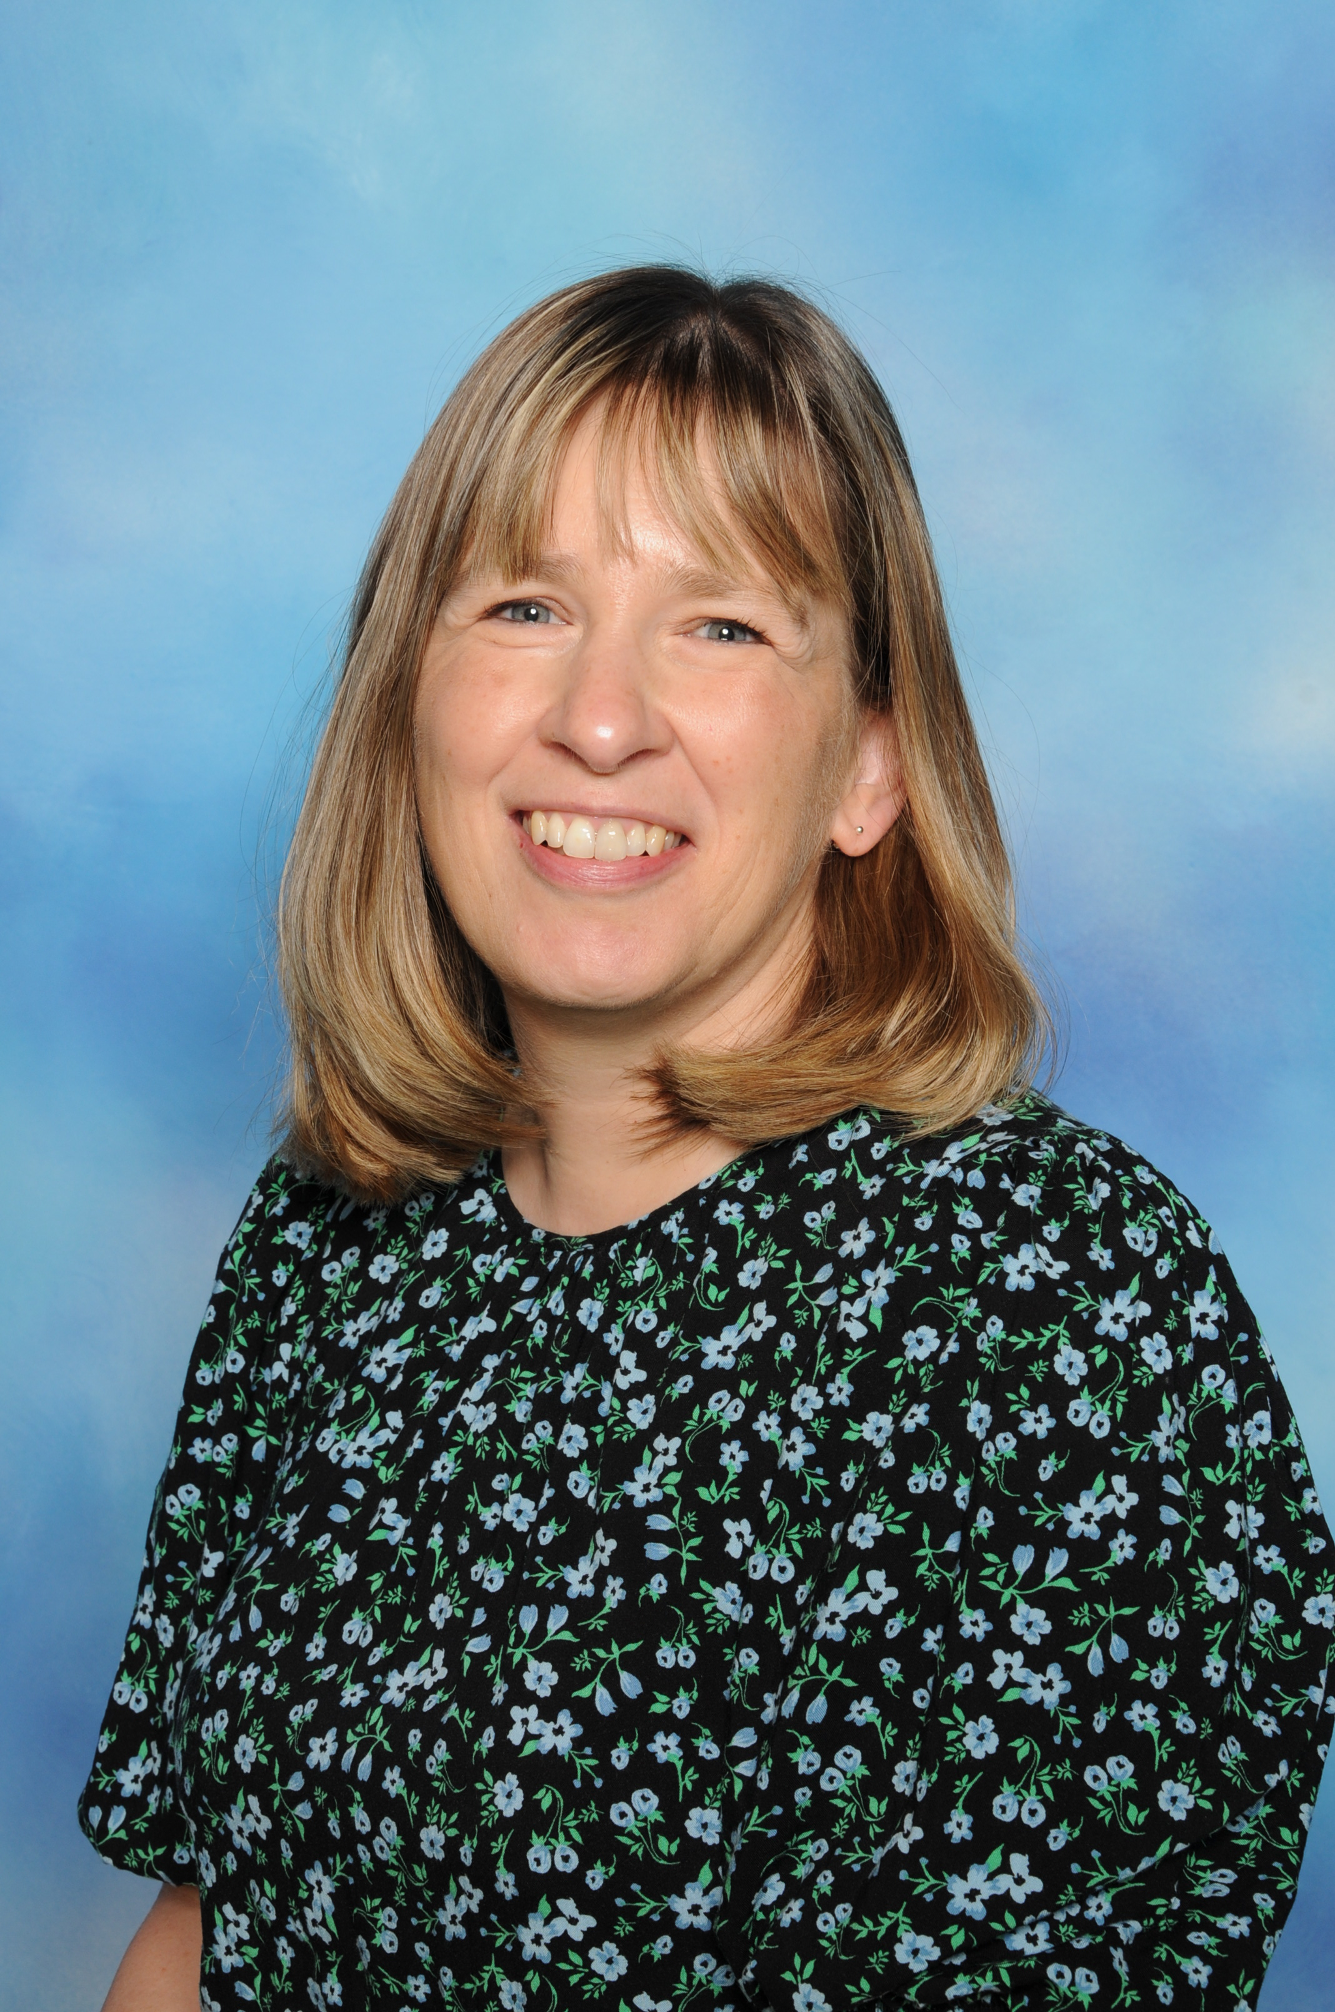

Miss Tibbs Mrs Fixter
Teaching assistant Teaching assistant
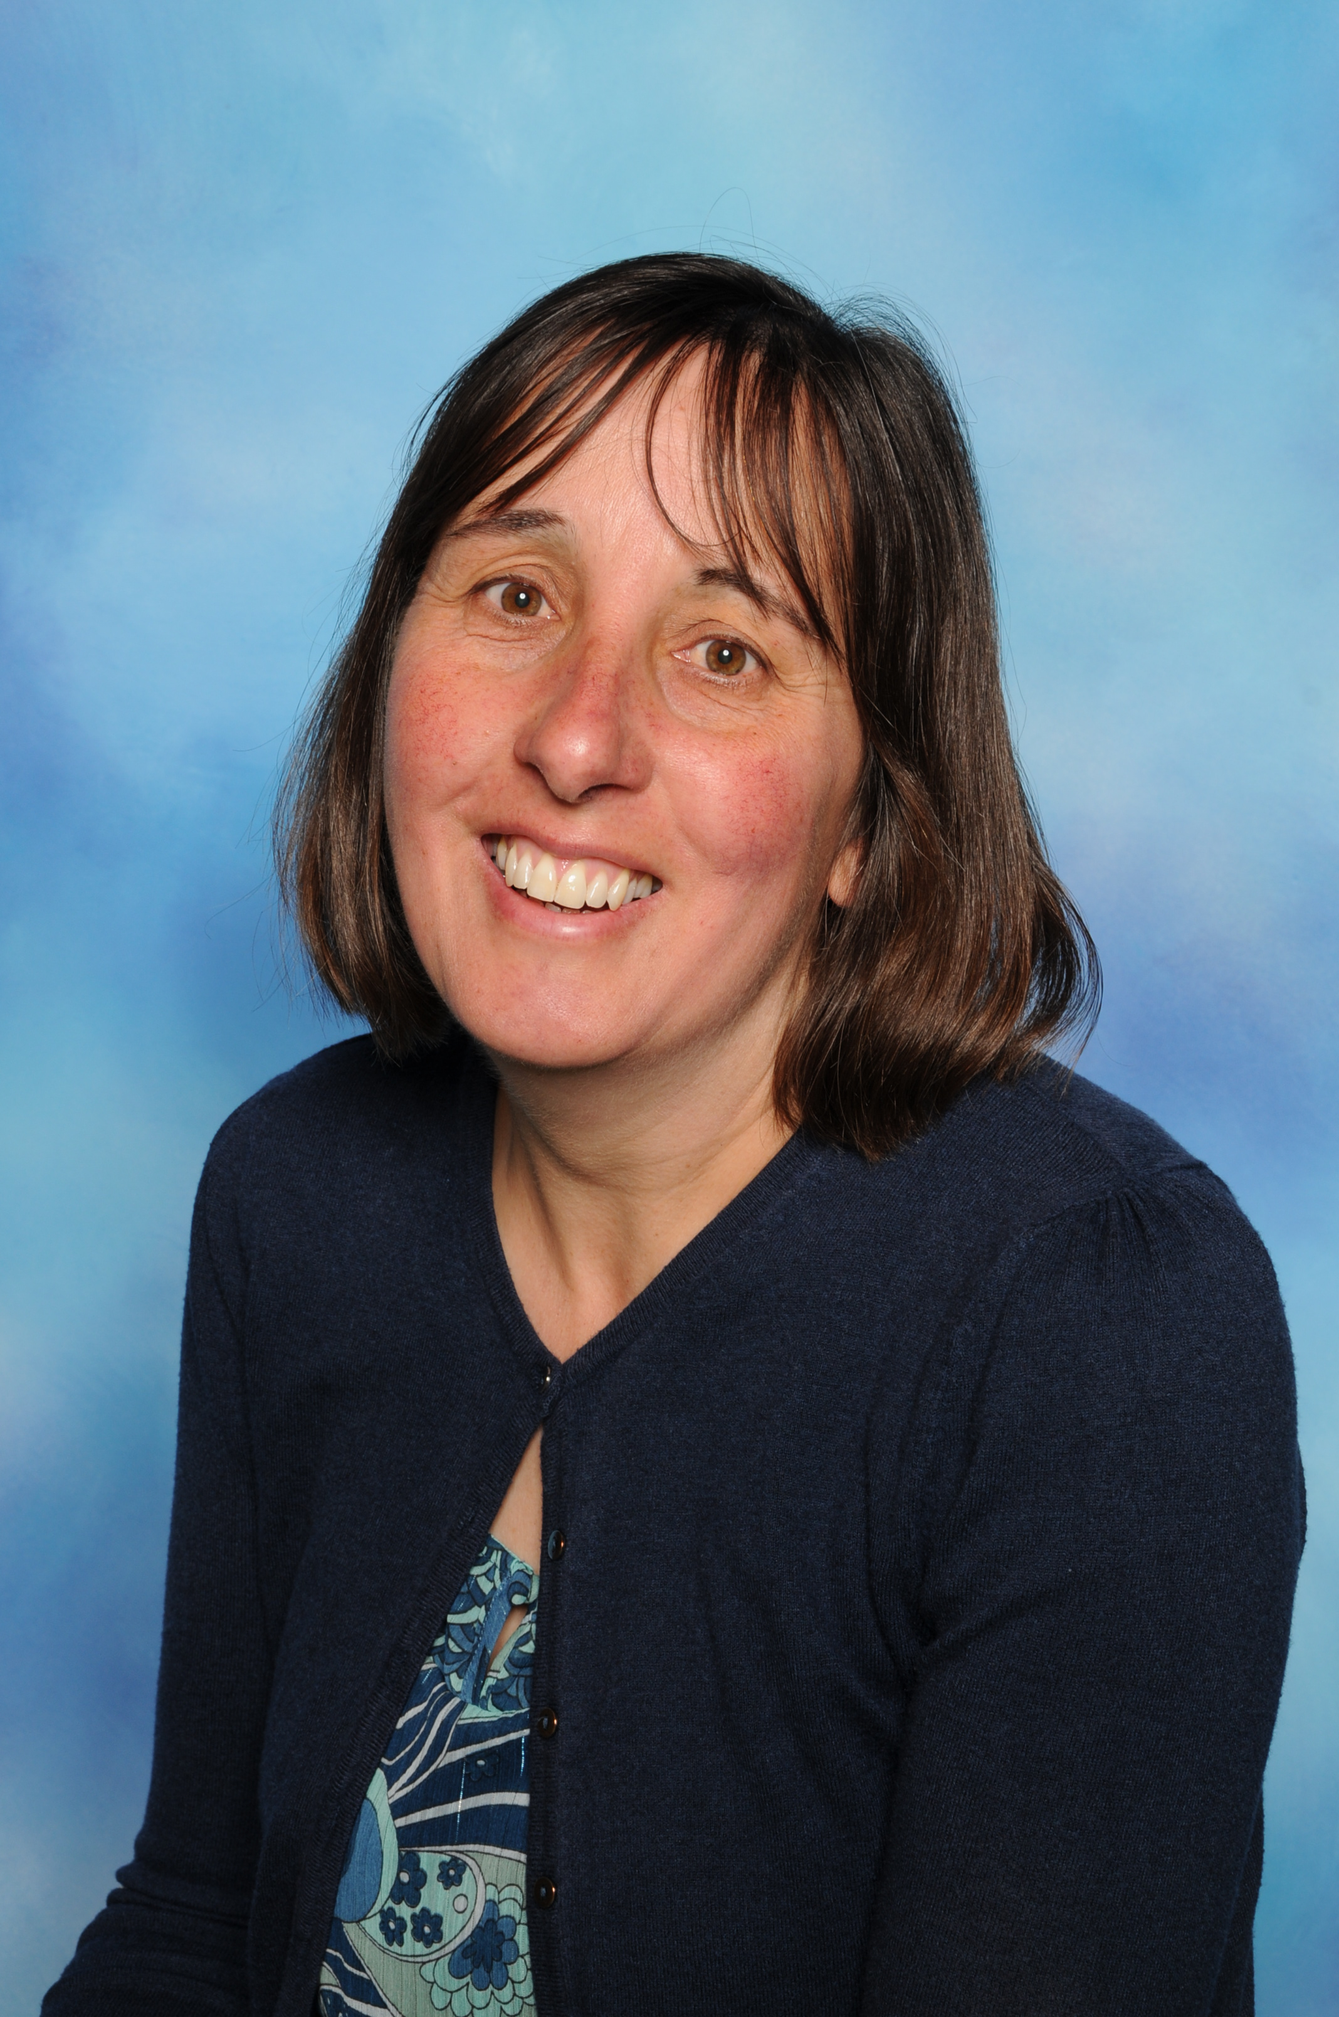

Mrs Stanley
Teaching assistant
If you want to support your child further, please explore the following websites over the term.
http://www.bbc.co.uk/schools/scienceclips/ages/5_6/growing_plants.shtml
http://www.bbc.co.uk/education/clips/zmwmpv4
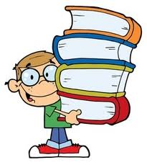
http://www.topmarks.co.uk/maths-games/5-7-years/addition-and-subtraction
http://resources.woodlands-junior.kent.sch.uk/interactive/literacy2.htm
https://www.oxfordowl.co.uk/for-home/maths/times-tables-tips/
https://play.edshed.com/en-gb/login

Homework- Homework is crucial and we expect it to be completed and handed in on time. It helps consolidate learning and build up your child’s confidence. Homework will be set every Friday and we ask that all homework books are handed in on Wednesdays. Projects will also be set every big term; more information will be sent home closer to the time.

We are so excited to continue to support and inspire your child, we have planned for a range of subjects to captivate all children over the year, please continue to support us. We plan to continue to provide a range of parent events, that we hope you can attend. Please do speak to us if you have ideas, questions or concerns over your child. It would be lovely to see any certificates or awards your child receives, or any exciting books your child has read so please do bring them in. Remember to inform of us of any change in circumstances and please ensure the office have up to date contact details.
We look forward to working with you and value your support and feedback.
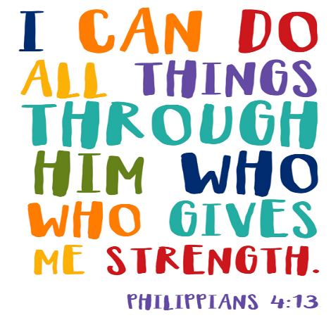
The Year Two Team.

